Setup Instructions:

1. Run InsightCM console batch file. This put a new device definition into the InsightCM server called “Innolux cRIO Data Logger”.

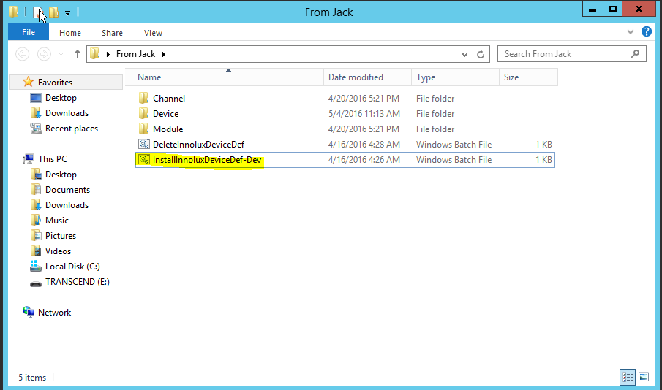

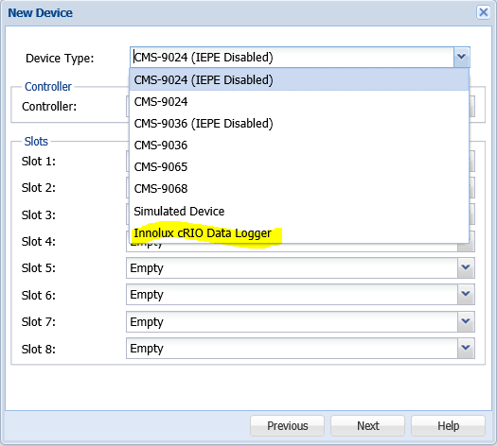

1. Restart “NI InsightCM” service.

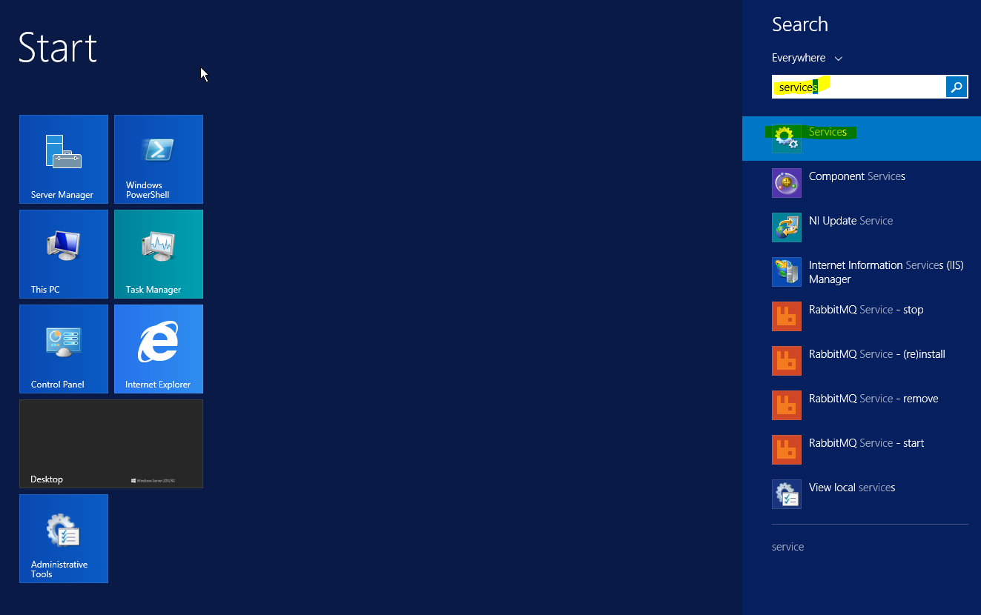

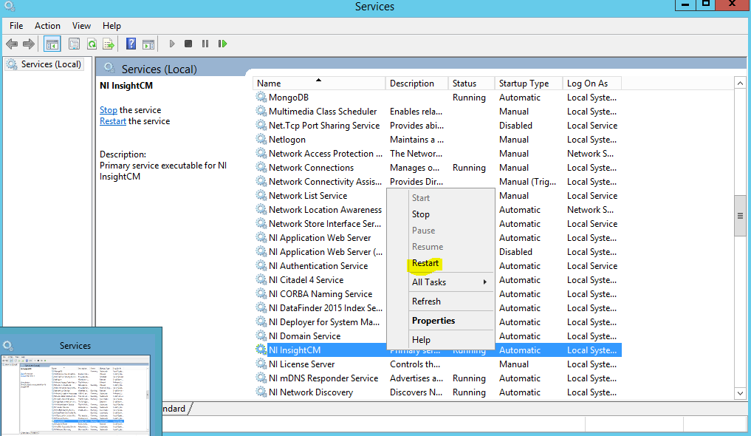

1. Load “Innolux cRIO Data Logger” system image (.lvappimg) into InsightCM Server.

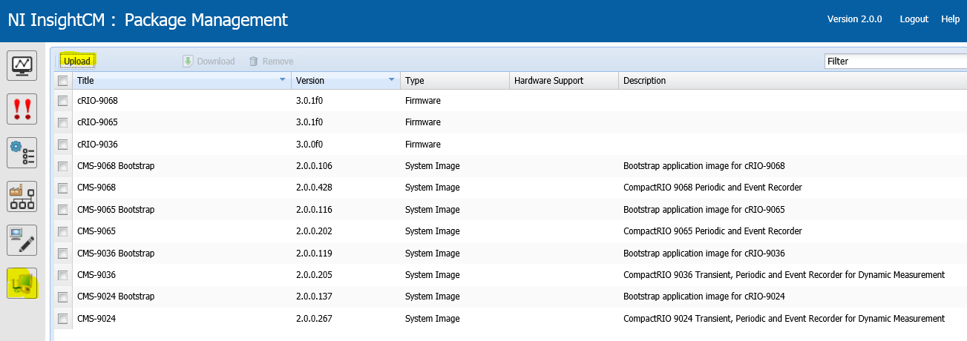

1. Define new spectral bands in server, if needed.

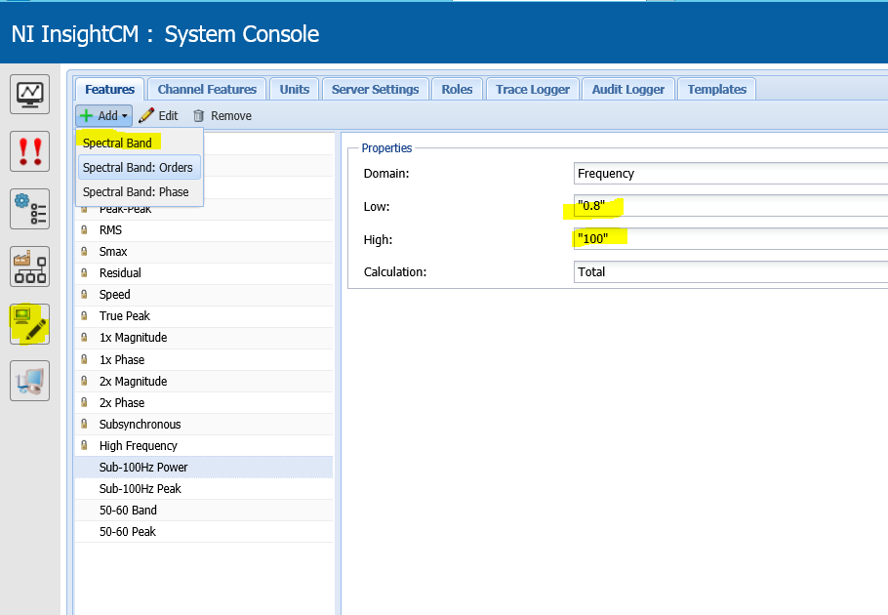

1. Prepare connection to cRIO as usual.
   1. Add device – Innolux Datalogger
   2. Define features
   3. Assign channel layout

Things to do:

1. Package cRIO code into rtexe. Make sure the file “BOP_6_9068_M9205.lvbitx” is in /home/lvuser/natinst/LabVIEW Data/InsightCM/FPGABitfiles. Use RAD to make into lvappimg.
2. Modify device def to include static modules. DONE
3. Modify device def for more sample rate options (500-1500 Hz) DONE
4. Modify device def to reflect new Application GUID (after step 1)
5. Test for 6 9205s, CPU usage.